**Vivekanand Education Society’s Institute of Technology**

**Department of AI &DS**



**Subject: Social Media Analytics**

**Class: D16ad**

| **Roll No: 30** | **Name: Suhanee Kandalkar** |
| --- | --- |
| **Practical No:8** | **Title:** Creative content Design |
| **DOP:** | **DOS:23/03/25** |
| **Grades:** | **LOs Mapped:** |
| **Signature:** |  |

**Title:** Creative content Design

**Aim:** To Design creative content for promotion of business on social media platforms.

**Theory:**

Social media has become a powerful tool for businesses to engage with their audience, build brand awareness, and drive sales. Designing creative content for social media promotions involves a combination of strategic planning, visual storytelling, and data-driven insights.

1. Importance of Creative Content in Social Media Marketing

Creative content plays a crucial role in capturing audience attention and conveying brand messages effectively. Well-crafted content can:

Enhance brand recognition.

Increase audience engagement (likes, shares, comments).

Drive traffic to websites or landing pages.

Boost conversions and sales.

2. Types of Social Media Content

Businesses can use various content formats depending on their goals and target audience:

Images and Graphics: High-quality visuals, infographics, and posters that communicate messages effectively.

Videos and Reels: Short-form videos, animations, or live streams that provide engaging storytelling.

Carousel Posts: A series of images or slides to showcase product features, testimonials, or tutorials.

Stories and Polls: Temporary content that boosts engagement and encourages direct interaction.

Blogs and Articles: Informative content that establishes thought leadership and educates audiences.

Memes and GIFs: Entertaining and relatable content that encourages shares and virality.

3. Key Elements of Effective Social Media Content

To design successful promotional content, businesses must focus on:

Target Audience Analysis: Understanding customer demographics, interests, and behaviors.

Brand Consistency: Using brand colors, fonts, and tone across all platforms.

Call-to-Action (CTA): Encouraging users to take specific actions like visiting a website, signing up, or purchasing.

Trending Hashtags & Keywords: Leveraging trends and keywords to improve discoverability.

Data Analytics: Tracking engagement metrics to optimize future content.

4. Tools for Creating Social Media Content

Several tools aid in designing visually appealing and engaging content, including:

Canva, Adobe Photoshop: For graphic design and image editing.

CapCut, InShot: For video editing and animations.

Hootsuite, Buffer: For scheduling and managing posts.

Google Analytics, Meta Insights: For tracking performance metrics.

5. Best Practices for Social Media Promotion

Post regularly and at peak engagement times.

Optimize content for different platforms (Instagram, Facebook, LinkedIn, Twitter, etc.).

Use A/B testing to determine what resonates best with the audience.

Leverage influencer marketing and collaborations for wider reach.

Encourage user-generated content to build community trust.

By integrating these elements, businesses can create compelling and impactful social media campaigns that drive meaningful results.

**OUTPUT:**

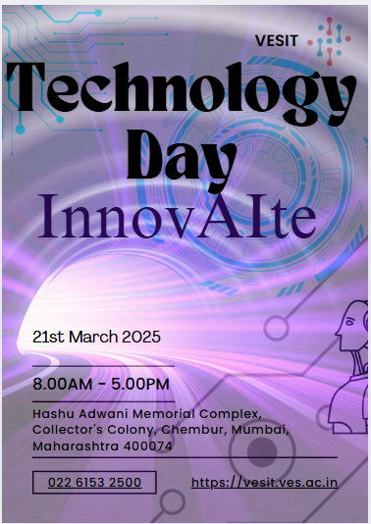

**Conclusion:**

Creative content is key to successful social media promotion, helping businesses engage audiences, build brand awareness, and drive conversions. By using diverse content formats, maintaining consistency, and leveraging data insights, businesses can maximize reach and impact. Adapting to trends and audience preferences ensures long-term success in the dynamic digital landscape. 🚀